2018 Lexington Community Land Trust
Homeownership Program

Application

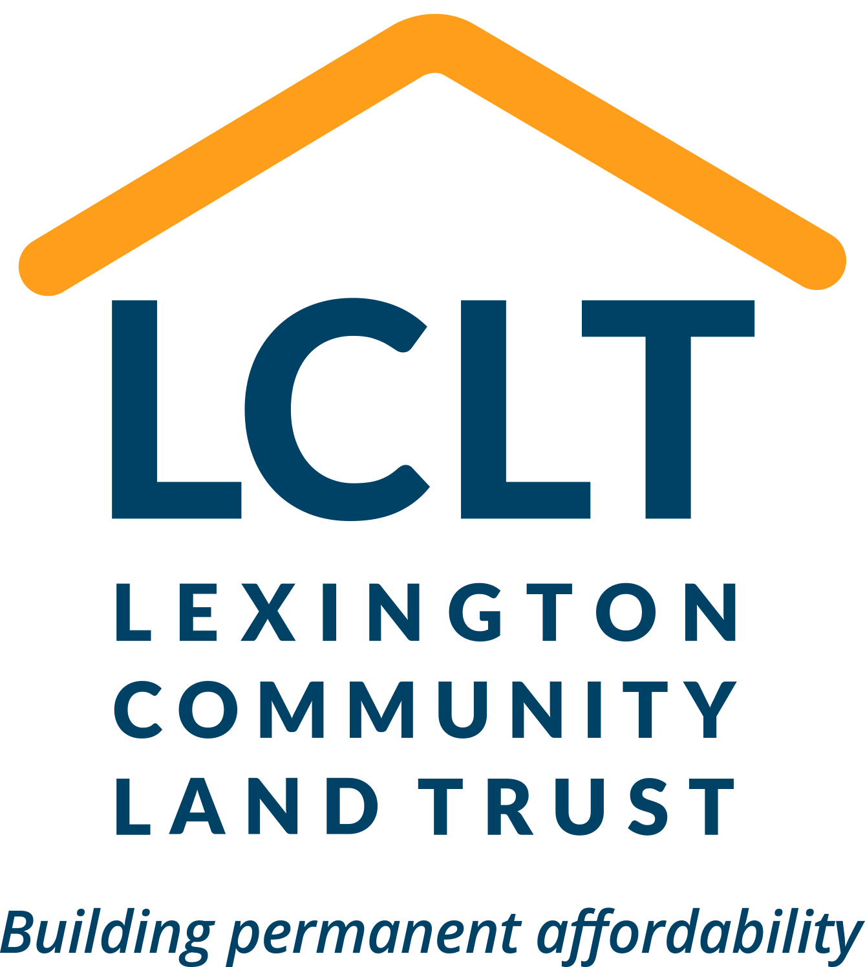

Welcome – The Lexington Community Land Trust Homeownership Program is committed to making permanently affordable housing a reality in Lexington. We look forward to helping you pursue your homeownership goals.

Lexington Community Land Trust (LCLT)
www.lexingtonclt.org

Lexington Community Land Trust Program provides permanently affordable homeownership opportunities in the Davis Park neighborhood. Applications are being accepted for new homes, which are available for sale now.

If you would like assistance in completing this application or need additional help in identifying and locating required documentation, please call 859-303-5223 or email info@lexingtonclt.org to set up an appointment.

We are here to help you achieve your homeownership goals!

Lexington CLT hOMEOWNERSHIP PROGRAM
HOW TO APPLY:
- Fill Out the Application:
Please fill out this entire application and submit the cover sheet and Parts 1-4. Keep the rest of the application for your own reference. Part 4 (Request for Verification of Employment form) must be completed by both you and your employer.

- Send or bring to Lexington Community Land Trust:
When you are finished with your application, please send it to PO Box 171, Lexington, KY, 40588, or bring it to Lexington CLT at 522 Patterson Street, Lexington, KY.

- Include Required Documents:
Submit copies of required documents. Do not send originals – you will need copies of most of these documents for your records and for your mortgage lender. Incomplete applications (those missing required documentation) will not be fully processed until all paperwork has been submitted. Please refer to the Required Documentation Checklist (attached) for a list of all required paperwork.

- Application Fee:
One $15 fee is required to process your application. Please attach the check or money order to your application (made payable to Lexington Community Land Trust). Cash will not be accepted.

ONCE YOUR APPLICATION HAS BEEN SUBMITTED:
- Processing Your Application:
The application process may take at least two weeks from the time your complete application has been submitted. Completing this application does not guarantee that you will be eligible for, or that you will successfully purchase a home through, the Lexington Community Land Trust Homeownership Program. Once LCLT has reviewed your application, someone will contact you to schedule a meeting to review your application one-on-one.

- Income Calculation:
Federal regulations require all programs to look at a "snapshot" of your gross income (net, if you are self-employed) and project it forward 12 months. Federal regulations also require that we calculate income from your assets and add that to your income. Don't be surprised if the income stated in the letter you receive looks different than what you might think of as your income. Feel free to ask the Lexington Community Land Trust how your income was calculated.

TO ACCOMPANY YOUR APPLICATION YOU MUST COMPLETE:
- Orientations:
You must attend a Lexington CLT orientation. Contact us for an Orientation schedule.

- Homebuyer Training Course:
This program requires that you attend a HUD-approved Homebuyer Education course prior to being approved for the program. Course information for the REACH, Inc. Homebuyer course is provided with this packet.

- Pre-Qualification or Pre-Approval Letter:
Please submit your pre-qualification or pre-approval letter, based on a tri-merge credit report an approved mortgage lender for CLT homes. Contact Lexington CLT for the most updated list of approved lenders.

PART 1: HOUSEHOLD INFORMATION

Section A - Please complete the following section for all household members age 18 or older who will occupy the property.

For household members younger than 18 years old, complete the information requested in Section B, on the next page. Make copies, if necessary, for any additional household members.

Primary Applicant – Name: _________________________________________________________________________

Current Address: ___________________________________________________________________________________

Phone: W) ______________ H) ______________ Cell) ______________ Email: ________________________________

Birthdate ___________ Gender __________ Number of people to live in your household ___________________

What language do you primarily speak? ________________
Is there a person in the household with a disability of long duration? □ Y □ N

Are you a full-time student? □ Y □ N Are you currently employed? □ Y □ N
Do you receive any other income? □ Y □ N In what city do you hold your primary job? ____________________

How long have you consecutively worked in this city? ________ Number of years living in your current city? ________
OPTIONAL Federal funding agencies require the collection of ethnicity and race data to track Fair Housing performance. This information will not be used to determine housing eligibility.
Ethnicity (please choose one):
□ Hispanic or Latino OR □ Not Hispanic or Latino OR □ Prefer not to answer
Race (please check one or more of the following):
American Indian or Alaska Native Asian Black or African American Native Hawaiian or Other Pacific Islander White/Caucasian

Adult Household Member #2 – Name: _________________________________________________________________

Current Address and Phone (if different from above): ______________________________________________________
Relationship to Primary Applicant __________________ Birthdate ________________ Gender _______________

Ethnicity ______________ Race __________________ (See text box under Primary Applicant section for options)
Are you a full-time student? □ Y □ N Are you currently employed? □ Y □ N
Do you receive any other income? □ Y □ N In what city do you hold your primary job? _______________

How long have you consecutively worked in this city? ________ Number of years living in your current city? _____

Adult Household Member #3 – Name: ________________________________________________________________

Current Address and Phone (if different from above): ______________________________________________________

Relationship to Primary Applicant __________________ Birthdate ________________ Gender _______________

Ethnicity ______________ Race __________________ (See text box under Primary Applicant section for options)
Are you a full-time student? □ Y □ N Are you currently employed? □ Y □ N
Do you receive any other income? □ Y □ N In what city do you hold your primary job? _______________

How long have you consecutively worked in this city? _______ Number of years living in your current city? ________
Section B - Please complete the following section for all household members younger than 18 who will occupy the property.

For Household Members 18 years old and older, please complete the information requested on the previous page.
Name | Birthdate | Gender | Ethnicity | Race | # of months during the year the child lives with you?
 |  |  | See text box in Section A for details

Section C - Other Information
- Are you currently married, have a domestic partner, or in a common law marriage? □ Yes □ No

- Do you or any household member own or have owned within the last 3 years any residential property/real estate or have interest in the same, including real estate in foreign countries? □ Yes □ No

If so, list address and state: _____________________________ Market Value ______________________
Have you sold the property? □ Yes □ No If you have sold the property, list the date of sale: ____________

If you have not sold your home please tell us about your mortgage:

Lender/Company: ____________________________________Unpaid Balance: _________________________

Do you have a second loan on this property? ______________ If so, what is the unpaid balance? ______________

- Have you been separated or divorced w/in the last 3 years? □ Yes □ No

- Do you spend money on child care so you can work? □ Yes □ No

- Do you have medical expenses (excluding insurance costs) that are
over 3% of your household gross annual income? □ Yes □ No

- Are you or your domestic partner, if you have one, over 62 yrs of age? □ Yes □ No

- Are you or your domestic partner, if you have one, disabled? □ Yes □ No

- If you have a real estate agent* to work with, please complete the following:

Agent:
_______________________________________________________________________________________________________
Agent Name Company Name Phone Fax Email address (if appl)

*A real estate agent is not necessary to purchase a CLT home.

PART 2: INCOME, DEBT AND ASSET INFORMATION
Please complete a separate Income and Asset Section for EACH individual in the household who receives income or holds assets or debts. Make copies of this part of the application if necessary. You do not need to provide employment income information for household members younger than 18. You do need to include assets held by children, or benefit income received by children.
On the following list, check YES if you receive the particular income, and check NO if you do not receive the income. You will need to provide verification for each item checked YES. (Refer to the Required Documentation Checklist in this packet.)

The following information is for: (Name) __________________________________________
- INCOME INFORMATION Gross income is the combined household income which includes, but is not limited to, job earnings, Social Security and Social Services income (for all in household), TANF, VA benefits, unemployment income, military pay, worker’s compensation payments, child support, alimony/maintenance payments, income from pensions or retirement plans, stocks, etc. Failure to report household income is considered fraud and can have serious consequences.

Employment Income (Do not include employment income of children younger than 18)
Self-Employment | Receive? |  | Type of Income | Anticipated Net Income for the Next 12 Months | Clarification  (as necessary)
 | YES | NO
Name of Business: | □ | □ | Self-Employment | $
Employer #1 | Receive? |  | Type of Income | Anticipated Gross Annual Income for the Next 12 Months | Clarification  (as necessary)
 | YES | NO
Name and Address of Employer:  Avg # hours work/week: _______ | □ | □ | Wages/Salaries | $
 | □ | □ | Overtime Pay | $
 | □ | □ | Commissions | $
 | □ | □ | Fees/Tips | $
 | □ | □ | Bonuses | $
Employer #2 | Receive? |  | Type of Income | Anticipated Gross Annual Income for the Next 12 Months | Clarification  (as necessary)
 | YES | NO
Name and Address of Employer:  Avg # hours work/week: | □ | □ | Wages/Salaries | $
 | □ | □ | Overtime pay | $
 | □ | □ | Commissions | $
 | □ | □ | Fees/Tips | $
 | □ | □ | Bonuses | $
PLEASE ADD ALL EMPLOYMENT INCOME AND RECORD THE TOTAL HERE $________________

Income Information cont. Name ___________________

Benefit Payments
Type of Income | Receive? |  | Anticipated Gross Annual Income for the Next 12 Months | Clarification  (as necessary)
 | YES | NO
Social Security | □ | □ | $
Supplemental Security Income (SSI) | □ | □ | $
Supplemental Security Disability Income (SSDI) | □ | □ | $
Worker’s Comp/Disability Pay/Benefits | □ | □ | $
Unemployment Insurance/Severance Pay | □ | □ | $
Insurance Policy Payments/Annuities | □ | □ | $
Pension/Retirement Benefits | □ | □ | $
PLEASE ADD ALL BENEFIT INCOME AND RECORD THE TOTAL HERE $____________________

Alimony and Child Support
Provide a copy of the court order for each type of support and indicate whether you are actually receiving it/them
Type of Support | Receive? |  | Anticipated Gross Annual Income for the Next 12 Months | Clarification  (as necessary)
 | YES | NO
Alimony/Maintenance | □ | □ | $
Child Support | □ | □ | $
PLEASE ADD ALL SUPPORT INCOME AND RECORD THE TOTAL HERE $____________________

Other Sources of Income
Type of Other Income | Receive? |  | Anticipated Gross Annual Income for the Next 12 Months | Clarification  (as necessary)
 | YES | NO
Money or gifts regularly given by persons not living in the home | □ | □ | $
Lottery winnings paid in periodic payments | □ | □ | $
Other Income (pls specify): | □ | □ | $
PLEASE ADD ALL “OTHER” INCOME AND RECORD THE TOTAL HERE $____________________
B. DEBT – Do you have any debt? r Yes r No If so, please list below.
Creditor’s Name | Unpaid Balance | Monthly Payment
 | $ | $
 | $ | $
 | $ | $
 | $ | $
 | $ | $
C. ASSET INFORMATION Name _______________________
An asset is anything of value that can be converted into cash.

Report the following assets: Cash held in savings accounts, checking accounts, safe deposit boxes, homes, etc., equity in rental property or other capital investments, cash value of stocks, bonds, Treasury bills, certificates of deposit and money market accounts, individual retirement and Keogh accounts (even though withdrawal would result in a penalty), retirement and pension funds, cash value of life insurance policies available to the individual before death, personal property held as an investment such as gems, jewelry, coin collections, antique cars, etc., lump sum or one-time receipts, such as inheritances, capital gains, lottery winnings, victim's restitution, insurance settlements and other amounts not intended as periodic payments, mortgages or deeds of trust held by an applicant.
- Do Not Report necessary personal property such as clothing, furniture, cars and vehicles specially equipped for persons with disabilities.

Bank Accounts
Have? |  | Name of Institution | Type of Account | Current Balance
YES | NO
□ | □ |  | Checking | $
□ | □ |  | Checking | $
□ | □ |  | Checking | $
□ | □ |  | Savings | $
□ | □ |  | Savings | $
□ | □ |  | Money Market | $
□ | □ |  | Money Market | $
□ | □ |  | Other (please specify) | $
PLEASE ADD ALL BANK ACCOUNT BALANCES AND RECORD THE TOTAL HERE $__________________

Other Assets
Have? |  | Name of Institution | Type of Investment | Current Value of Assets | Clarification Notes
YES | NO
□ | □ |  | Individual Stocks | $
□ | □ |  | Bonds | $
□ | □ |  | Mutual Funds | $
□ | □ |  | Trust Funds | $
□ | □ |  | Retirement Accounts (ie, IRA, Keogh, 401K, 403B, PERA) | $
□ | □ |  | Cash value of life insurance policy | $
□ | □ |  | Gift Money for down payment - provide a copy of the gift letter | $
□ | □ |  | Estimated Proceeds from Sale of Home | $
□ | □ |  | Value of Other Property (please specify) | $
□ | □ |  | Other Asset (please specify) | $
PLEASE ADD VALUE OF ALL OTHER ASSETS AND RECORD THE TOTAL HERE $_________________

PART 3: CERTIFICATIONS
It is our policy to verify all information contained in this application. In acknowledgement of this policy, please sign your name(s) where indicated.

I/We certify the following:
- All the information contained and submitted in support of this application is true and complete to the best of my/our knowledge and belief.

- I/We are aware that any misrepresentation will result in the forfeiture of my/our right to participate in the Lexington Community Land Trust Homeownership Program and may result in legal action against me/us.

- Consent to Release Information:

- I/We authorize representatives from the Lexington Community Land Trust Homeownership Program to supply and receive information to/from my/our financial institution(s), other housing/down payment assistance programs, my/our Realtor and/or my/our Mortgage Lender to verify the information contained in this application. This information includes, but is not limited to bank statements, employment status, income, outstanding debts and other financial information. I also authorize representatives from the Lexington Community Land Trust Homeownership Program to allow inspection and reproduction of any financial records or information in their possession. I/We understand that information in this application may be shared with funders for the purpose of funding compliance.

- I/We understand that the income I/we use to qualify for a mortgage loan amount must be the same as the income I/we claim in this application.

- I release all representatives from the Lexington Community Land Trust Homeownership Program from any and all liability arising from release of such information. This authorization is limited solely to information requested for the processing of my application for the Lexington Community Land Trust Homeownership Program.

- If I/we purchase a home under the Homeownership Program, I/we will occupy the home and agree to use the home as my/our primary and principal residence.

- I understand that completion of this application does not guarantee that my/our eligibility for program and/or that I/we will successfully purchase a home through the Lexington Community Land Trust Homeownership Program.

____________________________________________ ________________________________________
Signature Date Signature Date

Equal Opportunity: In accordance with the provisions of the Equal Opportunity Act and the Lexington Community Land Trust Homeownership Program’s policies, there will be no discrimination against an applicant for these benefits on the basis of age, source of income, sex, race, marital status, sexual orientation, national origin, religion or disability. If you or a member of your household is an individual with a disability, you have the right to request reasonable accommodation for that disability. The Lexington Community Land Trust Homeownership Program is committed to assuring that each individual has an equal opportunity to the use and enjoyment of the benefits of this program. For more information, please contact the Lexington Community Land Trust directly.

Confidentiality: In order to process an application, Lexington Community Land Trust Homeownership Program may supply and receive information as detailed in the “Consent to Release” clause above. Information may also be released to comply with the auditing requirements of program funders. With these two exceptions, all personal and identifying information on an application remains fully confidential.

PART 4: REQUEST FOR VERIFICATION OF EMPLOYMENT
SECTION A: APPLICANT - Please fill out Section A then give this form to your employer to complete Sections B and C.
Applicant's Name: |  | Employer's Name:
Address: ____________________________________  ____________________________________________  City, State, Zip Code |  | Address: _____________________________________  _____________________________________________  City, State, Zip Code
Phone: |  | Phone: |  | Fax:
I authorize you to release my employment information to the program checked above.

Employee’s Signature: _________________________________________ Date: ____________________

SECTION B: EMPLOYER - Please provide the following information for the above listed employee, then send the completed form to the email at bottom of page. Please call 859.303.5223 with any questions that you may have.
Present Position: |  | Dates of employment:
Probability of Continued Employment:

Current Gross Pay (Enter amount per Pay Period): $

Please circle frequency: hourly weekly 2x/month (24x/yr) bi-weekly (26/yr) monthly Other: __________
Average regular hours worked per week:

Overtime rate per hour: $ | Average number of overtime hours per week:
Commissions earned per week: $
Tips earned per week: $ | Annual Bonuses: $
Date and amount of applicant's last pay increase: |  |  | Date |  |  | Amount
Date and projected amount of applicant's next pay increase: |  |  | Date |  |  | Amount
Additional information (please explain seasonal work cycles and other pertinent information):
Employee's Total Gross Annual Income: $
SECTION C: EMPLOYER - Authorized Signature
Signature | Title |  |  |  | Date
Printed Name | Phone
Employers, please scan and email completed form to info@lexingtonclt.org

REQUIRED DOCUMENTATION CHECKLIST

-- Keep this page for your records --
The following documents (if applicable) must be submitted with your application or processing will be delayed. Please include information for all household members regardless of who will be on the title and/or mortgage of a home. Refer to supplemental applications from each program in which you are interested for other requirements.

Provide copies only as original documents cannot be returned.

r Completed application, signed and dated.

r A non-refundable $15 check or money order, made payable to Lexington Community Land Trust.

r A completed employer verification form or a letter from your employer, on letterhead, indicating your annual gross wage, start of employment, pay schedule, expected wage increases and any overtime, bonuses, tips or commissions.

r Copies of one month’s worth of your most recent pay stubs.

r Verification of all other sources of income (Social Security, Social Security Disability, pension, etc.).

r Complete copies of 2 years of your most recent Federal tax returns, all corresponding W2’s, schedules

r If you are self-employed (full or part-time), submit a year-to-date profit/loss statement and three years of federal income tax returns. Submit your estimate of the income you will receive for the next 12 months and an explanation as to how you came to that number.

r A statement from your financial institution documenting the 6-month average balance of your checking account or copies of the most recent 6 months of checking account statements.

r A copy of your most recent savings account statement, including the interest rate.

r A copy of the most recent statement from all other assets (IRA, 401K, cash value of life insurance policy, etc.) verifying the current balance, interest rate or annual dividend payment.

r If you have been separated or divorced within the past three years, submit a copy of your divorce decree and verification of the division of marital assets, court-ordered custody arrangements and child and/or alimony payments.

r If you currently own a home, submit a recent appraisal of that home or most recent Assessor’s statement and your most recent mortgage statement.

r If you had joint ownership in a property within the last 3 years and are no longer on the Title, submit a Quit Claim Deed showing the termination of your interest in the property.

r If you have signed a contract to buy a home, submit a copy of the contract.

- If you currently own other real property, such as vacant land and/or commercial property, submit a recent appraisal or Assessor’s statement and a recent mortgage statement.

CONTACT INFORMATION

Lexington Community Land trust
Mailing Address: Physical Address:
P.O. Box 171 522 Patterson Street, Suite 111
Lexington, KY 40588 Lexington, Kentucky 40508
859.303.5223
info@lexingtonclt.org
www.lexingtonclt.org

OTHER RESOURCES

R.E.A.C.H., Inc.
A service offering Home Ownership Training Courses (a HUD-approved homebuyer course is required by all programs), pre-purchase counseling, credit, budget, and mortgage default counseling.
(859) 455-8057 // www.reachky.com

Community Ventures Corporation
CVC offers an online HUD-approved homebuyer education course, financial counseling, down payment assistance, and foreclosure prevention.
(859) 231-0054 // www.cvky.org

